
Year 9

Mini Test 3

Ratio and Proportion

Resources allowed: Calculator and A4 notes page one side

Name: ______________________ Class: ______ Time: 25 minutes Total Marks: 23

Multiple Choice Section: Please circle the correct answer. (7 marks)
- What speed is required to run 100 m in 10 seconds?
A 5 m/s B 10 m/s
C 20 m/s D 25 m/s

- It takes 1 1/2 minutes to put 30 L of petrol in my car. At what rate is the petrol flowing?
A 20 L/min B 30 L/min
C 45 L/min D 90 L/min

- Cherries are on sale for $6.50 a kilogram. How many kilograms of cherries can I buy for $10?
A 0.65 kg B 0.94 kg
C 1.26 kg D 1.54 kg

- Which of the following is the best buy?
A 500 g box for $1.35
B 1 kg box for $2.50
C 5 kg bag for $11.25
D 10 kg bag for $23.00

- Tony has 24 marbles and Joni has 18. What is the simplest way to express the ratio of Tony’s to Joni’s marbles?
A 24 : 18 B 12 : 9
C 8 : 6 D 4 : 3

- Divide $200 in the ratio 2 : 3 : 5.
A $20, $30 and $50
B $20, $45 and $135
C $40, $60 and $100
D $50, $60 and $90

- 10 : 15 and which ratio below are inversely proportional?
A 2 : 3 B 4 : 3
C 3 : 4 D 9 : 6

Short Answer Calculation Section.

- In a scale drawing the length and width of a block of land are 10 mm and 6 mm respectively. If the real width of the land is 15 m, how long is it? (3 marks)

- Sam can paint two houses in a day, whereas it takes Roger two days to paint one house. If they work together, how long will it take for them to paint a house? (3 marks)

- A bus has a flat fee to hire it. It will cost $50 per person if there are 20 people on the charter bus. How many people would be needed to reduce the cost to $40 per person? (2 marks)

- The travel graph below describes Salah’s trip from home to the milk bar and back. (5 marks)
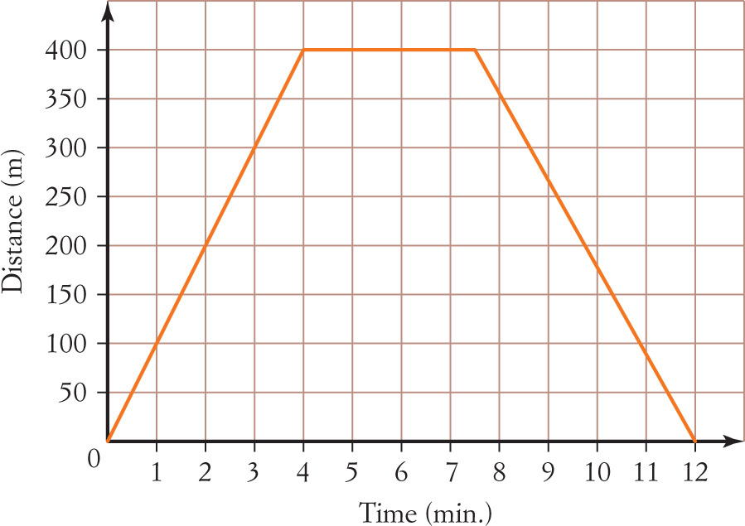
a How far is the shop from home?
________________________________________
b How long did she take to get to the milk bar?
________________________________________
c What speed did she walk to the milk bar?
________________________________________
________________________________________
d How long did she spend at the milk bar?
________________________________________

e What speed did she walk home from the milk bar?

_________________________________________

- An old puzzle goes as follows. If a hen and a half can lay an egg and a half in a day and a half, how long will it take a hen to lay a dozen eggs? You may assume half an egg means half the time to produce an egg. (3 marks)

End Test

